**Project Design Phase-II**

**Technology Stack (Architecture & Stack)**

| Date | 08 October 2022 |
| --- | --- |
| Team ID | PNT2022TMID17438 |
| Project Name | Project - Traffic and Capacity analytics for major ports |
| Maximum Marks | 4 Marks |

**Technical Architecture:**

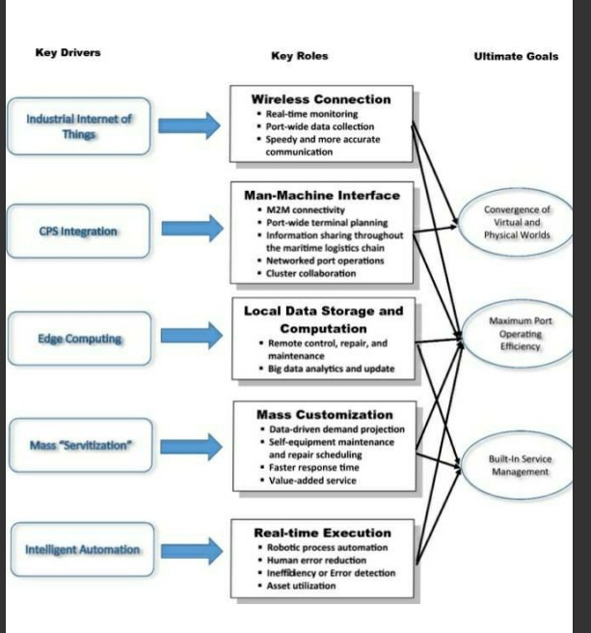

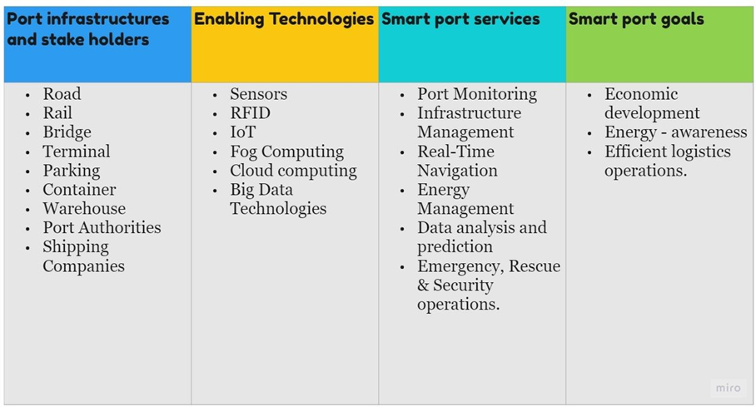

**Table-1 : Components & Technologies:**

| **S.No** | **Component** | **Description** | **Technology** |
| --- | --- | --- | --- |
|  | User Interface | How user interacts with application e.g. Web UI, Mobile App, Chatbot etc. | HTML, CSS, JavaScript |
|  | Application Logic-1 | Logic for a process in the application | Python |
|  | Application Logic-2 | Logic for a process in the application | IBM Watson STT service |
|  | Application Logic-3 | Logic for a process in the application | IBM Watson Assistant |
|  | Database | Data Type, Configurations etc. | MySQL |
|  | Cloud Database | Database Service on Cloud | IBM DB2, IBM Cloudant etc. |
|  | File Storage | File storage requirements | IBM Block Storage or Other Storage Service or Local Filesystem |
|  | External API-1 | Purpose of External API used in the application | IBM Weather API, etc. |
|  | External API-2 | Purpose of External API used in the application | Aadhar API, etc. |
|  | Machine Learning Model | Purpose of Machine Learning Model | Object Recognition Model, etc. |
|  | Infrastructure (Server / Cloud) | Application Deployment on Local System / Cloud Local Server Configuration:  Cloud Server Configuration : | Local, Cloud Foundry, Kubernetes, etc. |

**Table-2: Application Characteristics:**

| **S.No** | **Characteristics** | **Description** | **Technology** |
| --- | --- | --- | --- |
|  | Open-Source Frameworks | List the open-source frameworks used | Django |
|  | Security Implementations | List all the security / access controls implemented, use of firewalls etc. | e.g. SHA-256, Encryptions, IAM Controls, OWASP etc. |
|  | Scalable Architecture | Justify the scalability of architecture (3 – tier, Micro-services) | 3-tier, Micro- Services |
|  | Availability | Justify the availability of application (e.g. use of load balancers, distributed servers etc.) | Justify the availability of application  (e.g. use of load balancers, distributed servers etc.) |
|  | Performance | Design consideration for the performance of the application (number of requests per sec, use of Cache, use of CDN’s) etc. | number of requests per sec, use of Cache |